Promote educational equity and student access through data driven insights

Collage Name: Anna University Regional Campus Madurai

Team Name: Data Analysers

Team Members:
1. J. Harris- 910022104701
2.T. Jaya harini-910022104014
3. B. Sivasoruba-910022104028
4. T. Someaswaran- 910022104029
5. N. Sridevi-910022104030
6. S. Vidya-910022104032

Submitted by:
J. Harris – 910022104701

LINK:
https://us1.ca.analytics.ibm.com/bi/?perspective=dashboard&pathRef=.my_folders%2Finro&action=view&mode=dashboard&subView=model0000018f85313 04d_00000000

DASHBOARD SCREENSHOTS & ANALYSIS:

INTRO_PAGE SCREENSHOT:

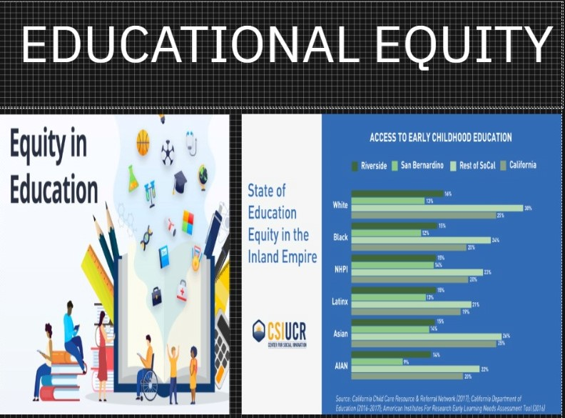

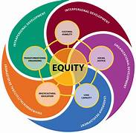
EDUCATIONAL EQUITY:
- Educational equity, also known as equity in education, is a measure of achievement, fairness, and opportunity in education. The study of education equity is often linked with the study of excellence and equity.

- Educational equity depends on two main factors. The first is fairness, which implies that factors specific to one's personal conditions should not interfere with the potential of academic success.

- The second factor is inclusion, which refers to a comprehensive standard that applies to everyone in a certain education system. These two factors are closely related and depend on each other for an educational system's success.

- Educational equity's growing importance is based on the premise that an person's level of education directly correlates with their quality of life and that an academic system that practices educational equity is thus a strong foundation for a fair and thriving society. But inequity in education is hard to avoid because of inequities in socioeconomic standing, race, gender, and disability. Educational equity also operates in a historical context.History can shape outcomes in education systems.
COMPARING RACE:

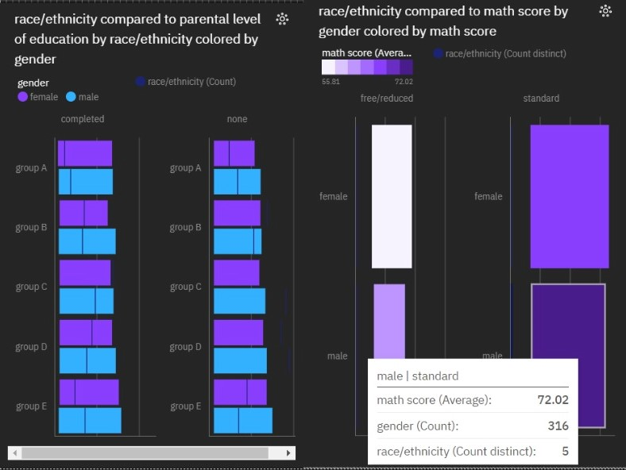
- Gender male has the highest average math score due to race/ethnicity group E.
- Test preparation course completed has the highest values of both parental level of education and reading score.
- Reading score and math score diverged the most when gender is female, and when reading score was 8.975 higher than the math score.
- Gender male has the highest average math score due to lunch standard.
- Lunch standard has the highest values of both math score and reading score.
- Reading score and math score diverged the most when gender is female, and when Reading score was 8.975 higher than the math score.

COMPARING LUNCH:

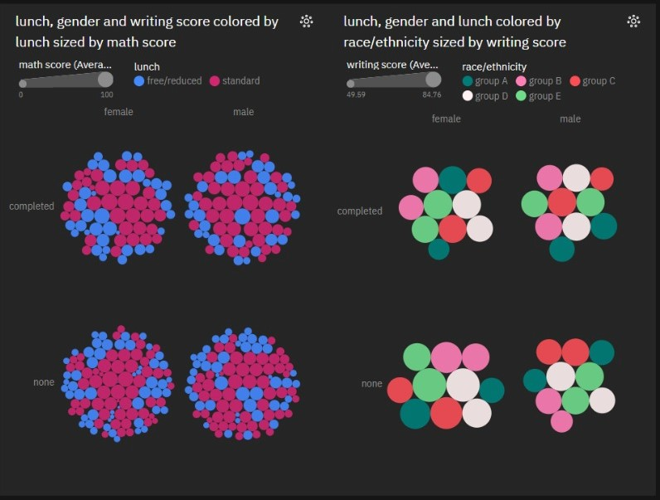

- Gender male has the highest average math score due to writing score 93.
- Lunch standard has the highest values of both math score and reading score.
- Test preparation course completed has the highest values of both math score and reading score.
- Gender female has the highest average writing score due to lunch standard.
- Lunch standard has the highest values of both writing score and math score.
- Race/ethnicity group E has the highest values of both writing score and math score.
GENDER COMPARISION :

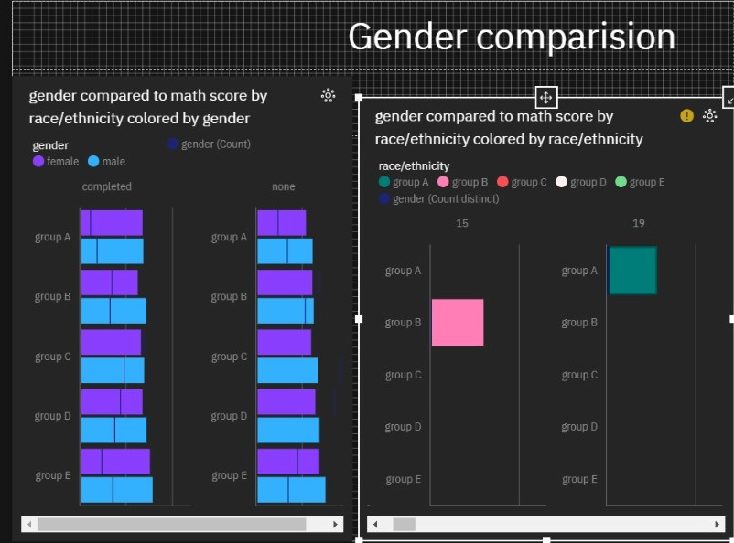

- Math score is most unusual when race/ethnicity is group E and group A.
- Female is the most frequently occurring category of gender with a count of 518 items with math score values (51.8 % of the total).
- Female is the most frequently occurring category of gender with a count of 518 items with test preparation course values (51.8 % of the total).
- Reading score and math score diverged the most when writing score is 23, and when reading score was 16 higher than the math score.
- Math score is most unusual when race/ethnicity is group E and group A.
- Math score is unusually low when writing score is 10 and 23.

COMPARISION OF PARENTIAL LEVEL OF EDUCATION:

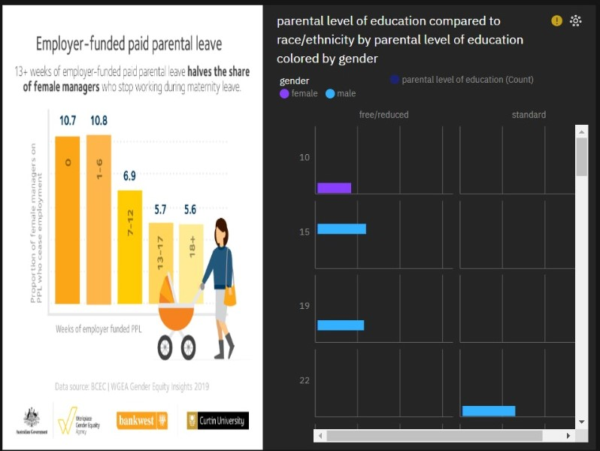

- Gender male has the highest race/ethnicity due to writing score 41.
- Lunch standard has the highest values of both reading score and math score.
- Reading score and math score diverged the most when writing score is 23, and when reading score was 16 higher than the math score.


EDUCATION :

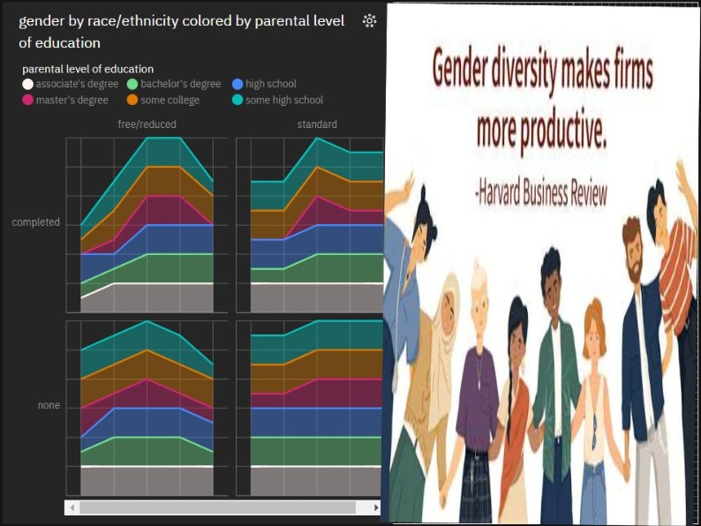

- Lunch standard has the highest values of both reading score and math score.
- Parental level of education master's degree has the highest values of both reading score and math score.
- Test preparation course completed has the highest values of both reading score and math score.

CONCLUSION :

Education equity aims to ensure that every student has access to the resources and opportunities they need to succeed, regardless of their background, socioeconomic status, or personal circumstances. Achieving education equity involves addressing systemic barriers and disparities that affect marginalized and underserved groups. This requires a multi-faceted approach that includes equitable funding, inclusive curricula, culturally responsive teaching, and supportive school environments.

